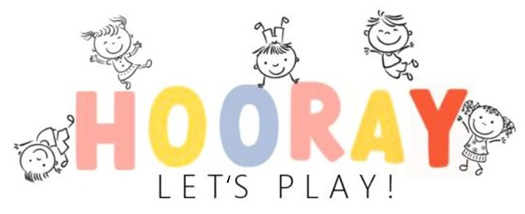

Release and Waiver Liability
This is a legal document between the client "the renter" and "Hooray Let's Play" which affects your legal rights, so please read carefully.
The renter desires to rent from Hooray Let’s Play, equipment to be used by the renter, his/her guests, invites or other individuals while in renters possession. Renter understands that use of this soft play equipment may, by its nature cause injury or harm to renter, his/her guests, invites or other individuals.
The renter does hereby freely, voluntarily, and without duress executes this release under the following terms:
- Waiver and Release: Renter understands and acknowledges that this release discharges Hooray Let's Play, from any liability or claim that the renter may have against Hooray Let's Play AND AFFILIATES with respect to any bodily injury, personal injury, illness, death, or property damage that may result from the renters use and possession of Hooray Let’s Play equipment. Renter does hereby release and forever discharges and hold harmless Hooray Let's Play and it's successors and assigns from any and all liability claims, and demands of whatever kind or nature, either in law or in equity, which arise or may hereafter arise from renters possession and use of Hooray Let's Play equipment.
- Insurance: Renter understands that insurance for liability, health, and medical or disability coverage in any way related to the rental of equipment under this agreement is the sole responsibility of Renter.
- Indemnification: Renter/Client agrees that he/she will indemnify and hold Hooray Let's Play harmless from any liability resulting from the use of Hooray Let's Play equipment by renter, his/hers assigns, heirs, guests, invites or other individuals utilizing the equipment while in renter's possession.
- Other: Renter expressly agrees that this release is intended to be as broad and inclusive as permitted by laws of the state of Minnesota and that this release shall by governed and interpreted in accordance with the laws of the state of Minnesota. Renter agrees that in the event that any clause or provisions of this release shall not otherwise affect the remaining provisions of this release, which shall continue to be enforceable.

By signing below I forfeit all rights to bring a suit against Hooray Let's Play AND AFFILIATES for any reason. In return I will also make every effort to obey safety precautions as listed in within and explained to me verbally, in efforts to keep the Hooray Let's Play experience positive, I have heard the safety rules and understand that I will ask for clarifications when needed.

Safety procedures/ Play Rules:
- PLAY AT YOUR OWN RISK
- ​Children must be supervised by an adult (18 yr old)/parent/guardian while in play area.
- NO Shoes, SNEAKERS, HIGH HEELS, FLIP FLOPS OR SANDALS are allowed on mats (play area) SOCKS MUST BE WORN AT ALL TIMES!
- NO food, drinks or sweets, gum allowed in play area
- NO Running in play area
- NO diving or throwing balls out of ball pit
- NO equipment should be removed from within play area
- No uneven size difference of players
- NO shoving, pushing, wrestling, piling or rough play in play area.
- ​Play areas are designed for children under 5 years ONLY.
- ​No paint stain/ mess-prone (i.e., glitter, slime, messy arty, temporary tattoos, face paint etc.) are not allowed in soft play areas
- No more that the recommended amount of players on unit at any time (Depending on play package)
- All sharp objects must be removed before play (including pens, pencils, jewelry, knives, eyeglasses, bling on pockets etc.
- DO NOT enter if you are pregnant or have physical problems

The Renter/Client Understands that:
- I am responsible for following the rules and safe procedures mentioned above by Hooray Let's Play in order to protect the equipment and provide a safe environment for me, my guests and any other individuals who will have access to Hooray Let's Play equipment while is in my possession.
- I AGREE TO RELEASE, DEFEND, INDEMNIFY, NOT SUE AND HOLD HARMLESS Hooray Let's Play, their principals, officers, owners, employees, equipment manufacturers from any claims, damages, (including medical fees, attorney fees). Injuries (including disabilities, paralysis and death) and expenses arising out of or resulting from my voluntary attendance/ participation at Hooray Let's Play.
- I am responsible for paying the deposit ($50) to book the date and the balance in full of the chosen soft play rental set 24 hours prior to the day of the event.
- I will give $200 in cash to Hooray Lets Play on the day of the event for a cleaning/damage deposit. I will get this back at the time of equipment pickup as long as the play equipment is not damaged or excessively dirty.
- If the equipment is returned in an extremely dirty condition at the time of pick up I will not be given back my $200 dollar cleaning fee.
- If there is any damaged or stolen soft play equipment I will be charged at an appropriate amount, i.e. cost of repair or replacement.
- Cancelation 7 business days or more prior to the event will receive a full refund of deposit. Cancellation less than 7 business days prior to the event will result in the loss of your deposit. If you do not receive a response via email within 24 hours, please call or text us at 952-220-2996.
- I also acknowledge the risks involved in Hooray Let's Play AREAS. These include but are not limited to any CHOCKING HAZARDS, FALLING, BREAKING ETC. while in use. I understand that I am participating voluntarily, and that all risks have been made clear to me. Additionally, I do not have any conditions that will increase my likelihood of experiencing injuries while engaging in this activity.
- ***The novel coronavirus, Clovid-19, has been declared a worldwide pandemic by the World Health Organization. Clovid-19 is contagious and believed to spread from person to person. Our agreement is for a small gathering/stay at home play area and social distancing must be used for set up and take down. Please follow WHO's guidance for safety measures on Clovid-19. By signing this you are agreeing to these methods for set up and will not find Hooray Let's Play accountable for any Clovid-19 claims or medical fees.
By sending the form below I forfeit all rights to bring a suit against Hooray Let's Play AND AFFILIATES for any reason, In return I will also make every effort to obey safety precautions as listed in writing and explained to me verbally, in efforts to keep the Hooray Let's Play experience positive, I have read, heard, and understand safety rules and understand that I will ask for clarification when needed.

Signature:_________________________________ Date:_________

